Title Of Project

Online Blood Donation System

Table of Contents

Title Page Number

- Certificate
- Acknowledgement
- Introduction to Online Blood Donation System
- Project Overview
- Project Description
- Objectives
- Project Code and Screen Layout
- Testing and Future work
- Conclusion

Acknowledgement

The goal was fixed , the moves were calculated and I moved full of enthusiasm, figurant keen interested there were time , when it proved to be on uphill task , the goal seeming beyond my reach. But as the work progressed my determination and will power grow stronger and the completion of this work further confirmed my belief that, “where there is a will there is a way”.
I am thankful to my guide Dr.Anand Kr. Pandey, Dr. Rakesh Kr. Pandey, Er. Ravi Bhushan Yadav and Mr. Sanjeet Kr. Sharma for his constant encouragement and support to complete the project. He motivated me through his personal and his “never say die” spirit.
I specially would like to express my gratitude and debtless to my friends someway or other and been linked with the project from the one.
I am also grateful to project lab for providing conductive environment.
I would also thank my parents for supporting me in this Project work.

Project Overview

The project entitled “Online Blood Donation System” is done to make the manual process easier by making it a computerised system for registering and maintaining details of the donor or other people.

The project can be used to store useful data online , and to automate the storing and retrieval of data. It is very helpful in maintaining the record of the user like name , address , contact information, email address and other information.

The entered data can also be updated or deleted as per the requirement of the user.
The user need to signin and update the information of their choice. All details are processed very easily.

Project Description

The project named “Online Blood Donation System” is done to make the manual process easier by making it a computerised system for maintaining all the records.

The user sign up in the directory and then log in their account all store information and all the data is stored in the database. This system is very simple and efficient.

Blood Donation System proposed to be an automate database management and transaction. This stores username, address, contact no., email address , resident addres. It also provide facility of advanced search. It provides data storing with graphical user interface.

The following are involved in this project: Donor Details, Blood Banks, Blood Group etc.

Objectives

The main objective of this project are summarised below:

- To design and develop a user friendly efficient computerised Blood Donation System.
- An accurate system without data redundancy.
- Secured data storage for authority end.
- To provide a graphical user interface.
- To store large amount of data.
- To develop a flexible system which can update and delete the various entered records.
- Computerisation that can be helpful as means of saving time and money.

Data Flow Diagram

A data flow diagram is the best and easiest tool to represent the flow of the data in the project. It is otherwise known as bubble chart. It has the purpose of clarifying system requirements and identifying major transformation that will become programs in the system design. It is the major starting point in the design phase that functionally decomposes the requirement specification down to the lowest level of detail.
It has four major symbol :
A square represents source or destination
A arrow represents the data flow
A circle represents the process
An open rectangle represents a data store.
‘
Add Donor

Online
Blood Donation System
View Donor
About Donation
Donation Camps

Project Code &
Screen Layouts

Database Design :
Database name - Database
Table used - Name, BloodGroup, Address, Contact Number

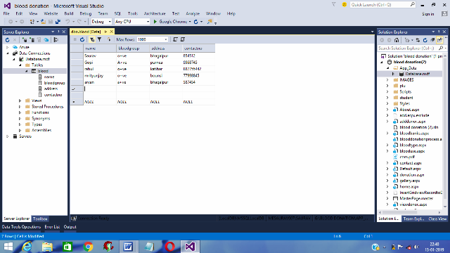

Home Page(.aspx)

<%@ Page Title="" Language="C#" MasterPageFile="~/MasterPage.master" AutoEventWireup="true" CodeFile="home.aspx.cs" Inherits="home" %>
<asp:Content ID="Content1" ContentPlaceHolderID="HeadContent" Runat="Server">
</asp:Content>
<asp:Content ID="Content2" ContentPlaceHolderID="MainContent" Runat="Server">
<div style="height: 387px; width: 845px">
<form id="form">
<div align="right"
style="width: 733px; margin-left: 2px; height: 28px;">
<asp:LinkButton ID="LinkButton1" runat="server" onclick="LinkButton1_Click"
Font-Bold="True" ForeColor="#003366" Height="20px"></asp:LinkButton>
&nbsp;&nbsp;
<asp:LinkButton ID="LinkButton2" runat="server" onclick="LinkButton2_Click"
Font-Bold="True" ForeColor="#003366" Height="20px"></asp:LinkButton>
&nbsp;&nbsp;
<asp:LinkButton ID="LinkButton3" runat="server" onclick="LinkButton3_Click"
Font-Bold="True" ForeColor="#003366" Height="20px"></asp:LinkButton>
</div>

<br />
<div style="width: 97px; float: left; height: 320px;" align="left">
<asp:Image ID="Image1" runat="server" Height="342px"
ImageUrl="~/IMAGES/93.jpg" Width="233px" style="margin-top: 2px" />
</div>
<div style="float: left; height: 233px; width: 518px; margin-left: 23px; z-index: 1; left: 435px; top: 159px; position: absolute;"
align="center">
<asp:Label ID="Label1" runat="server" Font-Bold="True" ForeColor="#CC6600"
Text="Blood Donation Process" Width="400px" Font-Size="Large"></asp:Label>
<br />
<br />

<font color="red" size="5">Preparation<br /></font>

the day before, focus on drinking plenty of water prior to your donation. Eat a hearty meal the night before your donation and get plenty of rest. Eat a well-balanced meal one to two hours prior to donation and remember to drink water throughout the day limit caffeine intake. If you are donating
platelets, do not take aspirin or products containing aspirin for at least 48 hours prior to donation. Please consult your physician prior to stopping any medications. For a list of medications acceptable for donation.

<font color="red" size="5">Donations and Iron Deficiency<br /></font>

is important for making red blood cells and transporting oxygen. Loss of red blood cells through blood donation may deplete the body of iron over time, and frequent blood donors may become low on iron before becoming anemic. Young women are particularly at risk of low iron due to blood
loss during their menstrual cycles. Diet alone may not be enough to replace iron,
especially if you have gastrointestinal issues or do not eat red meat. If you think you may be at risk of low iron,
you may consider calling your physician or taking an oral iron supplement. Do not take iron without consulting your doctor if you have
any family history of too much iron in the body.

</div>
</form>
</div>
</asp:Content>

Master Page(.master)

<%@ Master Language="C#" AutoEventWireup="true" CodeFile="MasterPage.master.cs" Inherits="MasterPage" %>
<!DOCTYPE html PUBLIC "-//W3C//DTD XHTML 1.0 Transitional//EN" "http://www.w3.org/TR/xhtml1/DTD/xhtml1-transitional.dtd">

<script src="student/js/validation.js" type="text/javascript"></script>
<link href="plu/Calendar/calendar/css/smoothness/jquery-ui-1.7.1.custom.css" rel="stylesheet" type="text/css" />
<script src="plu/Calendar/calendar/js/jquery-1.3.2.min.js" type="text/javascript"></script>
<script src="plu/Calendar/calendar/js/jquery-ui-1.7.1.custom.min.js" type="text/javascript"></script>

<html xmlns="http://www.w3.org/1999/xhtml">
<head runat="server">
<title>BloodDonationCamp</title>
<link href="Styles/Site.css" rel="stylesheet" type="text/css" />
<asp:ContentPlaceHolder id="HeadContent" runat="server">
</asp:ContentPlaceHolder>
<style type="text/css">
#Form1
{
height: 758px;
width: 1109px;
}
.style1
{

width: 29px;
}
</style>
</head>
<body>
<form id="form1" runat="server">
<div class="page">
<div class="header"
style="background-color: #FFFFFF; top: 0px; left: 2px; height: 712px;">
<div class="title" style="width:30px";>
<h1 style="background-color: #CC0000; width: 1087px; height: 101px;">
<asp:Image ID="Image1" runat="server" ImageUrl="~/IMAGES/6.jpeg"
style="z-index: 1; left: 4px; top: 1px; position: absolute; width: 1103px; height: 100px; margin-top: 0px;" />
</h1>
<h1 align="center"
style="background-color: #CC0000; width: 1087px; height: 32px;">
&nbsp;&nbsp;&nbsp;&nbsp;&nbsp;&nbsp;&nbsp;&nbsp;&nbsp;&nbsp;&nbsp;&nbsp;&nbsp;&nbsp;&nbsp;&nbsp;&nbsp;&nbsp;&nbsp;&nbsp;&nbsp;&nbsp;&nbsp;&nbsp;&nbsp;&nbsp;&nbsp;&nbsp;&nbsp;&nbsp;&nbsp;&nbsp;&nbsp;&nbsp;&nbsp;&nbsp;&nbsp;&nbsp;&nbsp;&nbsp;&nbsp;&nbsp;&nbsp;&nbsp;&nbsp;&nbsp;&nbsp;&nbsp;&nbsp;&nbsp;&nbsp;&nbsp;&nbsp;&nbsp;&nbsp;&nbsp;&nbsp;&nbsp;&nbsp;
Blood donation PROJECT</h1>
</div>
<div class="clear hideSkiplink"
style="background-color: #CC0000; height: 31px;">

<asp:Menu ID="NavigationMenu" runat="server" CssClass="menu"
EnableViewState="false" IncludeStyleBlock="false" Orientation="Horizontal"
BackColor="#00CCFF" BorderStyle="Solid" Font-Bold="True" ForeColor="White">
<Items>
<asp:MenuItem Text="Blood Donate" Value="Blood Donate">
<asp:MenuItem NavigateUrl="~/home.aspx" Text="Blood donation process"
Value="Blood donation process"></asp:MenuItem>
</asp:MenuItem>
<asp:MenuItem NavigateUrl="~/About.aspx" Text="About">
</asp:MenuItem>
<asp:MenuItem Text="Blood Facts" Value="Blood Facts">
<asp:MenuItem NavigateUrl="~/bloodtype.aspx" Text="Blood Types"
Value="Blood Types">
</asp:MenuItem>
<asp:MenuItem NavigateUrl="~/blooduse.aspx" Text="Blood use" Value="Blood use">
</asp:MenuItem>
<asp:MenuItem NavigateUrl="~/donation.aspx" Text="Type of Donation"
Value="Type of Donation"></asp:MenuItem>
</asp:MenuItem>

<asp:MenuItem NavigateUrl="~/bloodbanks.aspx" Text="Blood Bank"
Value="New Item"></asp:MenuItem>

<asp:MenuItem Text="Contact Us" Value="Contact Us" NavigateUrl="~/contact.aspx" ></asp:MenuItem>
</Items>
</asp:Menu>
</div>
<div>
&nbsp;</div>
<div style="width: 188px; float: left;">
<table cellpadding="1" cellspacing="1"
style="border: thick double #000000; width: 154px; color: #FFFFFF; background-color: #003366; font-weight: bold;"
border="1">
<tr>
<td class="style1">
&nbsp;</td>
</tr>
<tr>
<td class="style1">
<asp:HyperLink ID="HyperLink2" runat="server" Width="168px"
Font-Underline="False" Font-Bold="True" ForeColor="White"
Font-Names="Mangal" NavigateUrl="~/gallery.aspx" BackColor="#CC0000"> Gallery</asp:HyperLink>
<asp:HyperLink ID="HyperLink1" runat="server" Width="168px"
Font-Underline="False" Font-Bold="True"

ForeColor="White" Font-Names="Mangal" NavigateUrl="~/adddonor.aspx" BackColor="#CC0000"> AddDonor</asp:HyperLink>
<asp:HyperLink ID="HyperLink3" runat="server" Width="168px"
Font-Underline="False" Font-Bold="True" ForeColor="White"
Font-Names="Mangal" NavigateUrl="~/viewdonor.aspx" BackColor="#CC0000"> ViewDonor</asp:HyperLink>
</td>
</tr>
</table>
</div>
<div class="main" style="float: right">
<asp:ContentPlaceHolder ID="MainContent" runat="server"/>
</div>
</div>
</div>
<div class="footer">
Copyright &copy; Krishna_Aryan_Akash_Ashish_Rahul
</div>
</form>
</body>
</html>

Add Donor(.aspx)

<%@ Page Language="C#" AutoEventWireup="true" CodeFile="adddonor.aspx.cs" Inherits="adddonor" %>

<!DOCTYPE html>

<html xmlns="http://www.w3.org/1999/xhtml">
<head runat="server">
<title></title>
<style type="text/css">
.auto-style1 {
font-size: x-large;
font-weight: bold;
}
</style>
</head>
<body>
<form id="form1" runat="server">
<div style="height: 66px">
<table style="height: 241px; width: 395px; z-index: 1; left: 420px; top: 135px; position: absolute">
<tr>
<td>Name</td>
<td><asp:TextBox ID="TextBox1" runat="server"></asp:TextBox></td>
</tr>
<tr>
<td>Blood Group</td>
<td><asp:TextBox ID="TextBox2" runat="server"></asp:TextBox></td>
</tr>
<tr>
<td>Address</td>
<td><asp:TextBox ID="TextBox3" runat="server"></asp:TextBox></td>
</tr>
<tr>
<td>Contact No</td>
<td><asp:TextBox ID="TextBox4" runat="server"></asp:TextBox></td>
</tr>
<tr>
<td colspan="2" align="center">
<asp:Button ID="Button1" runat="server" Text="Button" OnClick="Button1_Click" />
</td>
</tr>
</table> &nbsp;&nbsp;&nbsp;&nbsp;&nbsp;&nbsp;&nbsp;&nbsp;&
<br />
nbsp;&nbsp;&nbsp;&nbsp;&nbsp; <span class="auto-style1">ADD DONORS</span></div>
</form>
</body>
</html>

Add Donor(.aspx.cs)

using System;
using System.Collections.Generic;
using System.Linq;
using System.Web;
using System.Web.UI;
using System.Web.UI.WebControls;
using System.Data;
using System.Data.SqlClient;

public partial class adddonor : System.Web.UI.Page
{
SqlConnection con = new SqlConnection(@"Data Source = (LocalDB)\MSSQLLocalDB;AttachDbFilename=|DataDirectory|\Database.mdf;Integrated Security = True");
protected void Button1_Click(object sender, EventArgs e)
{
con.Open();
SqlCommand cmd = con.CreateCommand();
cmd.CommandType = CommandType.Text;
cmd.CommandText = "insert into blood values('"+TextBox1.Text+"','"+TextBox2.Text+"','"+TextBox3.Text+"','"+TextBox4.Text+"')";
cmd.ExecuteNonQuery();
Response.Write("<script>alert('record inserted successfully');</script>");
con.Close();
}
}

About(.aspx)

<%@ Page Title="" Language="C#" MasterPageFile="~/MasterPage.master" AutoEventWireup="true" CodeFile="About.aspx.cs" Inherits="About" %>

<asp:Content ID="Content1" ContentPlaceHolderID="HeadContent" Runat="Server">
</asp:Content>
<asp:Content ID="Content2" ContentPlaceHolderID="MainContent" Runat="Server">
<div align="center"
style="color: #FFFFFF; font-weight: bold; font-size: xx-large; background-color: #CC0000">
Six Things You Might Not Know About Blood Donation:
</div>
<div style="color: #003366">
<br />
Have you ever thought about donating blood but decided not to for some reason or another? You’re not alone! Thirty-seven percent of the population in our area is eligible to give blood, but less than four percent of those eligible actually give.

There is always a need for blood. And the process is always life-prolonging, life-enhancing, or life-saving. Here are a few more things you might not know about the blood donation process and the importance of being a frequent donor.

<br /><br />
1. Blood cannot be manufactured.
There is no substitute for human blood. Patients requiring a blood transfusion rely solely on the kindness of volunteer donors to provide them with this life-saving treatment.
<br />
2. There are not warehouses filled with unused blood.
It is a common misconception that there is plenty of blood to go around. Because it is living tissue, blood has a limited shelf life. Red blood cells must be used within 42 days following donation, platelets only have a five-day shelf life, and plasma can be frozen and stored for up to one year. To maintain a safe and sufficient blood supply, Carter BloodCare relies on donors giving regularly for patients in the community.
<br />
3. Giving with your community blood center is the best way to support the blood needs of local patients.
National blood collection organizations can collect locally to support hospitals in another state, but giving with an independent community blood center like Carter BloodCare means the first priority is to help local patients – your friends, colleagues, and neighbors. Blood can be sent elsewhere if local patient needs are met or there is a rare blood match required outside the area.
<br />
4. You cannot get an infectious disease by donating blood.
Each time the phlebotomist collects blood, he/she uses a brand new supply kit that includes a single-use, sterile needle. Our phlebotomists are also trained in procedures that are unique to blood banking to result in a safe and positive experience for each donor.
<br />

5. There is a need for ALL blood types.
Although blood centers often run short of type O-, all blood types are essential. As the universal donor, O- is most often used in emergencies and when the patient’s blood type is unknown. However, the blood in greatest demand is the type required by a patient when the order is placed. In other words, we want to store all types to help a variety of patients.
<br />
6. Summer and winter are always tough months for the blood industry.
High school blood drives contribute more than 20 percent to our annual blood collections. However, when school is not in session, we often struggle to have enough donors come through the doors. With the lack of school drives combined with the winter holidays and summer festivities, many blood centers run low of all blood types. July, August, December, and January are the toughest months for us to keep blood on the shelves. If you are contemplating donating blood, consider donating during our times of urgent need. And it’s also a good time to host a blood drive.
</div>
</asp:Content>

BloodType(.aspx)

<%@ Page Title="" Language="C#" MasterPageFile="~/MasterPage.master" AutoEventWireup="true" CodeFile="bloodtype.aspx.cs" Inherits="bloodtype" %>
<asp:Content ID="Content1" ContentPlaceHolderID="HeadContent" Runat="Server">
</asp:Content>
<asp:Content ID="Content2" ContentPlaceHolderID="MainContent" Runat="Server">
<div align="center"
style="color: #FFFFFF; font-weight: bold; font-size: xx-large; background-color: #CC0000">
About Blood Types
</div>
If a doctor talks about your blood type, usually he or she is referring to two things: your type in the ABO system and Rhesus (Rh) factor.

Human blood type is determined by antigens on the red blood cells. An antigen is a structure on the cell surface that causes a human immune response reacts to if the structure is foreign to the person’s body. As a result, blood type match is of critical importance. The donor’s blood type is identified at the Blood Centre, and the patient’s blood type is determined before transfusion.
The ABO system

The most important blood group system is ABO, in which your blood is classified as A, B, O or AB. This is determined by two antigens on the red blood cells:

<br />
<li> A — red blood cells have only the A antigen
<li> B — red blood cells have only the B antigen
<li> AB — red blood cells have the A and B antigens
<li> O — neither A nor B antigen

If a person has A, B or O blood type, their plasma contains antibodies that destroy the antigens that the person doesn’t have. For example: If you have blood type A, it’s imperative that you don’t receive a B type transfusion, as you have antibodies that will destroy B antigens. If you have blood type O, you have antibodies that will fight the A and B antigens.

If a person has blood type AB, they don’t have such antibodies, and they can accept transfusions from all other blood types. Thus AB blood type people can be termed universal patients.

But O Rh negative donors can be called universal donors, as red blood cells from such donors can be used for transfusions for all patients.
The Rh system

A person’s Rh group can be positive (+) or negative (-).This depends on the existence of antigen RhD on the red blood cells. If the RhD antigen is present, a person is Rh positive and if RhD is not present, the person is Rh negative.
If a person is Rh negative, they may develop antibodies on exposure to Rh positive blood (such as during transfusions or pregnancy). These antibodies may cause pregnancy complications for Rh negative women giving birth to an Rh positive child.
In addition, about 30 other blood group systems have been identified besides the ABO and Rh blood group systems. Of these, the clinically most significant are Kell, Kidd and Duffy systems. Donors are also tested for Kell blood group.

How is the blood type identified?
The person’s blood is combined with a reagent with antibodies.

For instance, three drops of a donor’s blood are placed on a slide or dish. Anti-A reagent is added to the first drop, anti-B reagent to the second one and anti-D – RhD reagent – to the third one. If agglutination is noted in the first drop, that shows that the person has A antigen. If the same thing doesn’t happen in the second drop, the person has no B antigen; and if agglutination is seen in the third drop, the person is Rh positive. We can say based on that example that the donor is A positive.

Ensuring a match between donor and patient is extremely important; otherwise a patient may have a dangerous reaction to the transfusion.
Blood types heredity and frequency in the Estonian population

People inherit traits equally from their mother and father. So inherited genes are always in two parts: one part mother, one part father .

When we examine blood type heredity, we should keep in mind that:
<li>there are two copies of most of our genes
<li> we pass on only one of the copies to our children (randomly)
<li> genes come in different versions (alleles)
</asp:Content>

BloodUse(.aspx)

<%@ Page Title="" Language="C#" MasterPageFile="~/MasterPage.master" AutoEventWireup="true" CodeFile="blooduse.aspx.cs" Inherits="blooduse" %>

<asp:Content ID="Content1" ContentPlaceHolderID="HeadContent" Runat="Server">
</asp:Content>
<asp:Content ID="Content2" ContentPlaceHolderID="MainContent" Runat="Server">
<font size="3">
Processing
After you give blood, we begin testing and processing your blood so it can be used to give life. For each donation, blood samples are tested to make sure it can be transfused to patients safely.
Processing begins by separating the blood using a centrifuge. The centrifuge spins the blood, separating the components by density into three parts: red blood cells, plasma, and platelets. Each component is collected into a separate storage bag and stored in our monitored storage devices.
Transfusion
Transfusion is the process by which a doctor or medical professional prescribes blood products for a patient using blood donated by someone like you. On average, one in every seven hospital patients is in need of a life-saving blood transfusion.
Blood transfusions are commonly used for patients undergoing organ transplants, bone marrow transplants, heart surgery, burn treatments, or those who have been in an automobile accident. Cancer patients are one of the most common recipients of blood products.

Research
Carter BloodCare works with local and regional academic institutions and select commercial entities and vendors in developing new services and products related to blood transfusion, cellular therapy and supportive services. Personal information will never be shared.
ABOUT US

With origins in the 1950s, Carter BloodCare is one of Texas' largest blood centers, providing 300,000 units of life-saving blood and blood components to patients in North, Central, and East Texas annually. We save lives by making transfusion possible.
NEWSLETTER

Stay connected with the latest information from Carter BloodCare in your local community.

</font>
</asp:Content>

BloodUse(.aspx)

<%@ Page Title="" Language="C#" MasterPageFile="~/MasterPage.master" AutoEventWireup="true" CodeFile="blooduse.aspx.cs" Inherits="blooduse" %>

<asp:Content ID="Content1" ContentPlaceHolderID="HeadContent" Runat="Server">
</asp:Content>
<asp:Content ID="Content2" ContentPlaceHolderID="MainContent" Runat="Server">
<font size="3">
Processing

After you give blood, we begin testing and processing your blood so it can be used to give life. For each donation, blood samples are tested to make sure it can be transfused to patients safely.
Processing begins by separating the blood using a centrifuge. The centrifuge spins the blood, separating the components by density into three parts: red blood cells, plasma, and platelets. Each component is collected into a separate storage bag and stored in our monitored storage devices.
Transfusion
Transfusion is the process by which a doctor or medical professional prescribes blood products for a patient using blood donated by someone like you. On average, one in every seven hospital patients is in need of a life-saving blood transfusion.
Blood transfusions are commonly used for patients undergoing organ transplants, bone marrow transplants, heart surgery, burn treatments, or those who have been in an automobile accident.

Cancer patients are one of the most common recipients of blood products.
Research
Carter BloodCare works with local and regional academic institutions and select commercial entities and vendors in developing new services and products related to blood transfusion, cellular therapy and supportive services. Personal information will never be shared.
ABOUT US

With origins in the 1950s, Carter BloodCare is one of Texas' largest blood centers, providing 300,000 units of life-saving blood and blood components to patients in North, Central, and East Texas annually. We save lives by making transfusion possible.
NEWSLETTER
Stay connected with the latest information from Carter BloodCare in your local community.
</font>
</asp:Content>

View Donor(.aspx)

<%@ Page Language="C#" AutoEventWireup="true" CodeFile="viewdonor.aspx.cs" Inherits="viewdonor" %>
<!DOCTYPE html>
<html xmlns="http://www.w3.org/1999/xhtml">
<head runat="server">
<title></title>
<style type="text/css">
.auto-style1 {
color: #FF9933;
font-family: "Lucida Bright";
font-size: large;
}
</style>
</head>
<body>
<form id="form1" runat="server">
<div>
<center>
<asp:GridView ID="GridView1" runat="server" style="z-index: 1; left: 543px; top: 199px; position: absolute; height: 133px; width: 187px">
</asp:GridView>
<span class="auto-style1"><strong>LIST OF DONORS</strong></span></center>
</div>
</form>
</body>
</html>

View Donor(.aspx.cs)

using System;
using System.Collections.Generic;
using System.Linq;
using System.Web;
using System.Web.UI;
using System.Web.UI.WebControls;
using System.Data;
using System.Data.SqlClient;
public partial class viewdonor : System.Web.UI.Page
{
protected void Page_Load(object sender, EventArgs e)
{
show_data();
}
private void show_data()
{
DataTable dt = new DataTable();
SqlConnection con = new SqlConnection(@"Data Source=(LocalDB)\MSSQLLocalDB;AttachDbFilename=|DataDirectory|\Database.mdf;Integrated Security=True");
SqlCommand cmd = new SqlCommand("select * from blood", con);
con.Open();
SqlDataReader dr = cmd.ExecuteReader();
dt.Load(dr);
GridView1.DataSource = dt;
GridView1.DataBind();
con.Close();
}
}

Home Page

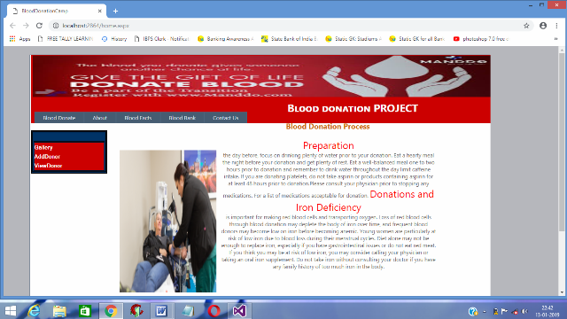

Add Donor

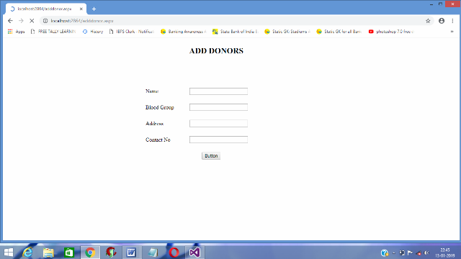

About

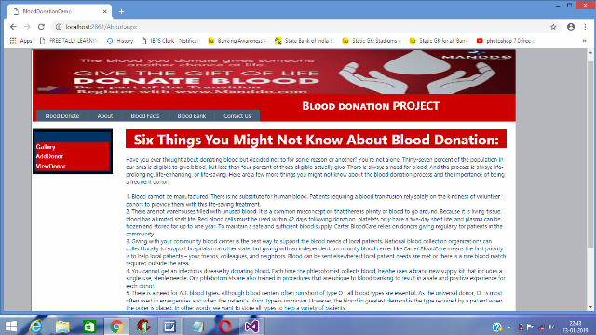

Blood Type

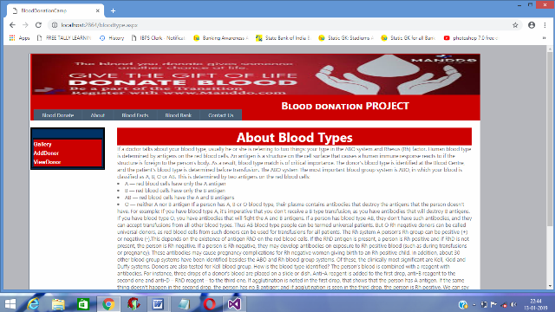

Testing & Future Work

Software testing is the process of evaluation a software item to detect differences between given input and expected output. Also to access the feature of a software item. Testing accesses the quality of the product. Software testing is a process that should be done during the development stage. In other words software testing is a verification and validation process.

Verification is the process to make sure the product satisfies the conditions inmposed at the end of the development phase. In other words , to make sure the product is built as per customer requirement.

Online Pizza Order System and Online Blood Donation System was tested using the following two techniques of application testing:
Unit testing:
- In the line of strategy the entire individual function and modules were put to test independently.
- By following this strategy all the errors in coding were identified and corrected.
- It was seen that the pages opens properly based on related menu based commands.
- It was tested whether all relevant menus , buttons , icons and other controls are displayed properly.
The main error that occurred during this project was connecting picture with database and retrieving from it.

Future Work
The project has been developed in a very short period of time and all efforts have been taken so that this project is very efficient in its execution.
There is still some scope of improvement in our project. The following list of enhancement that can be added incorporate into this project.
Database management can be updated which helps the administrator.
Scope could be changed.
Additional information could be added.
Barcode generation option can be given.
User picture could be updated.

Conclusion

The smart Online Pizza Order System Online and Blood Donation System is successfully designed and developed to fulfil the necessary requirements as identified in the requirement analysis phase, such as the system is very much user friendly , form level validation and field level validation are performing very efficiently .
The old manual system was suffering form a series of drawbacks. The Online Pizza Order System and Blood Donation project has been developed to meet the aspiration indicated in the modern age.

The end

